## Question 1

1. Sub-sampling the image changes the image resolution, since for each sub-sampling ratio, we skip pixels in the x and y direction based on the ratio. Figures 1 to 4 show the results obtained for each sub-sampling ratio.



Figure 1: Sub-sampling 2:1



Figure 2: Sub-sampling 4:1



Figure 3: Sub-sampling 8:1



Figure 4: Sub-sampling 16:1

1. Figures 5 to 8 show the results obtained via quantization. As can be seen, 1 and 2 bit quantization gives false contours.



Figure 5: 1 bit quantization



Figure 6: 2 bit quantization



Figure 7: 4 bit quantization



Figure 8: 6 bit quantization

1. It was observed that the perceived image quality differed greatly when having SNR as -30, -10, 0, 10 and 30 dB. The resulting image in these three cases are shown in figures 9, 10, 11, 12 and 13 respectively.



Figure 9: Gaussian noise with SNR = -30dB



Figure 10: Gaussian noise with SNR = -10dB



Figure 11: Gaussian noise with SNR = 0dB



Figure 12: Gaussian noise with SNR = 10dB



Figure 13: Gaussian noise with SNR = 30dB

1. The resulting image obtained by corrupting the pixels with i.i.d noise for impulse probability 0.1, 1, 5 and 10 percent is shown from figures 14 to 18 respectively. To calculate the SNR, the Pnoise was calculated by squaring each entry in the noise matrix and summing the result. Pimage was calculated in a similar manner, and the two powers divided by each other to arrive at the SNR. Log10 of this result was taken and then multiplied by 10 to arrive at SNR in dB. For 0.1% probability, the SNR = 30.81 dB. For 1% probability, SNR = 21.07 dB. For 5% probability, SNR = 14.17 dB. For 10% probability, SNR = 11.16 dB.



Figure 14: probability iid = 0.1%



Figure 15: probability iid = 1%



Figure 16: probability iid = 5%



Figure 17: probability iid = 10%

1. The Gaussian noise seems to add black pixels as noise in the image, whereas the i.i.d. one seems to add white impulsive pixels.

## Question 2

1. It was observed that with higher values of N, the blurring intensity increases. Figure 18 shows the image blurred with N = 20 and figure 19 shows the image blur with N = 5.



Figure 18: blur image with N = 20



Figure 19: blur image with N = 5

1. For this test, the SNR for Gaussian blur was set as 10dB and the resulting image is given in Figure 12. Figure 20 shows the result obtained when applying a 3 by 3 low pass filter on the noisy image. Figure 21 shows the result obtained by applying 5 by 5 low pass filter on the image. The filter was applied in frequency domain by taking FFT of the original image as well as the filter and convolving them. The results are obtained by then taking the inverse FFT of the convolution.



Figure 20: 3x3 low pass filter on image with Gaussian noise. SNR = 10dB



Figure 21: 5x5 low pass filter on image with Gaussian noise. SNR = 10dB

1. For this experiment, the probability of i.i.d. impulse was set as 10%, where the resulting noisy image is shown in figure 17. The result obtained by applying 3 by 3 low pass filter on this noisy image is shown in figure 22 and the result of 5 by 5 filter is shown in figure 23. This approach works because it blurs out the i.i.d. impulse created on the image, therefore fixing the noise.



Figure 22: 3x3 low pass filter on image with iid noise. Piid = 10%



Figure 23: 5x5 low pass filter on image with iid noise. Piid = 10%

1. The result obtained by applying the 3 by 3 median filter is shown in figure 24, while figure 26 shows the result of 5 by 5 median filter. This filter takes the median of every 3-by-3 subsection of the image and therefore, it would average out the i.i.d. impulse encountered in most cases.



Figure : 3x3 Median Filter



Figure 25: 5x5 median filter

1. Applying the high pass filter on the image gives the resulting image of figure 27. This seems to have inverted the intensity of pixels in the image, therefore giving a highlight effect.



Figure 26: High pass filter result

## Question 3

1. Figure 28 shows the 2-D fft plot result on the original image. **Frequencies up till 500Hz are present?? SHorouq!!!!**

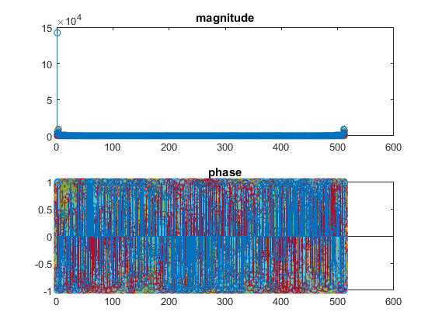

Figure 27: 2D FFT plot of Mandrill image

d) The magnitude of the image was taken by first taking the FFT of the mandrill image and then taking the absolute of the result, as shown in Figure 29. This shows how many different frequencies or intensities are present in the image.



Figure : Magnitude of 2D Fourier transform of Mandrill image

e)